Ancient Egyptian Hieroglyphics
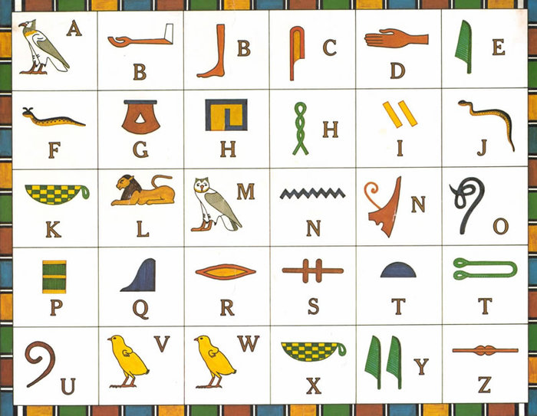

- Can you write your name using the ancient Egyptian hieroglyphics?

- What does this sentence say?

